SPI Slave with Single Port RAM

Team Name : m&m*’*s Team members :

* Monaya Wael Mohamed
* Mennatu-Allah Abd Elfattah
  + 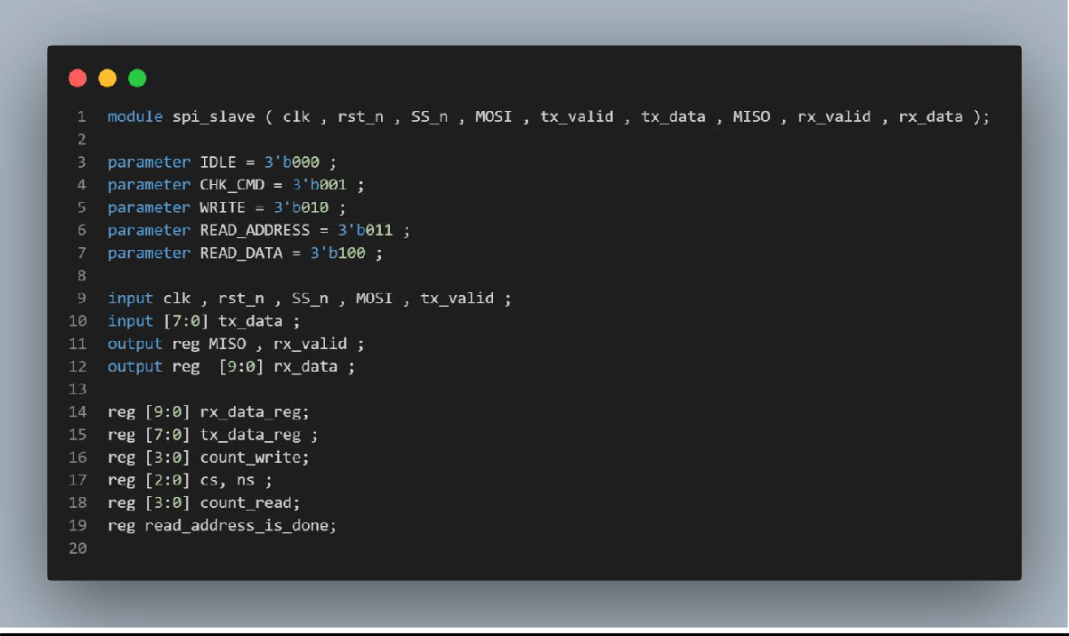SPI Code

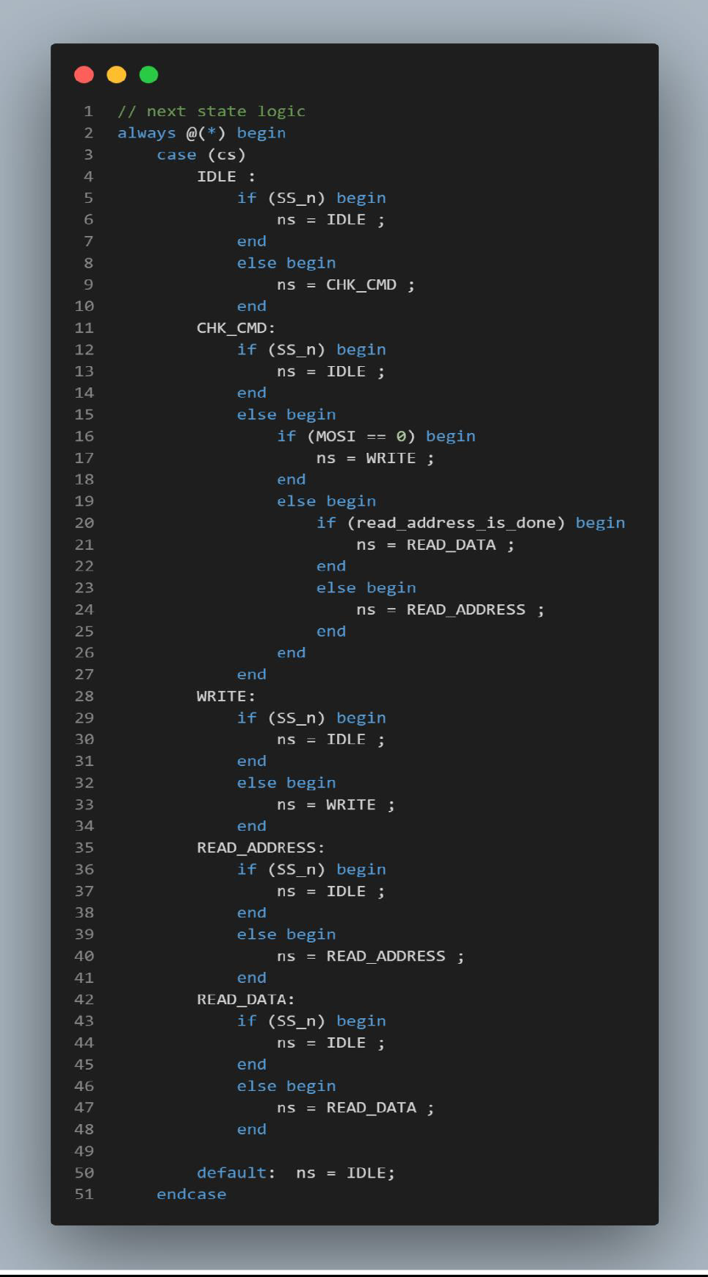

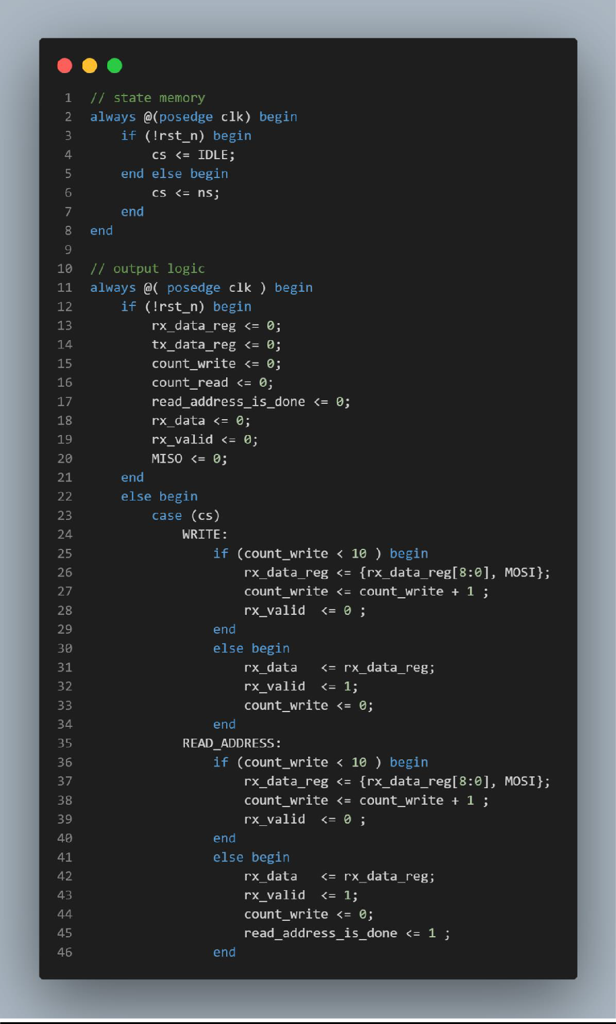

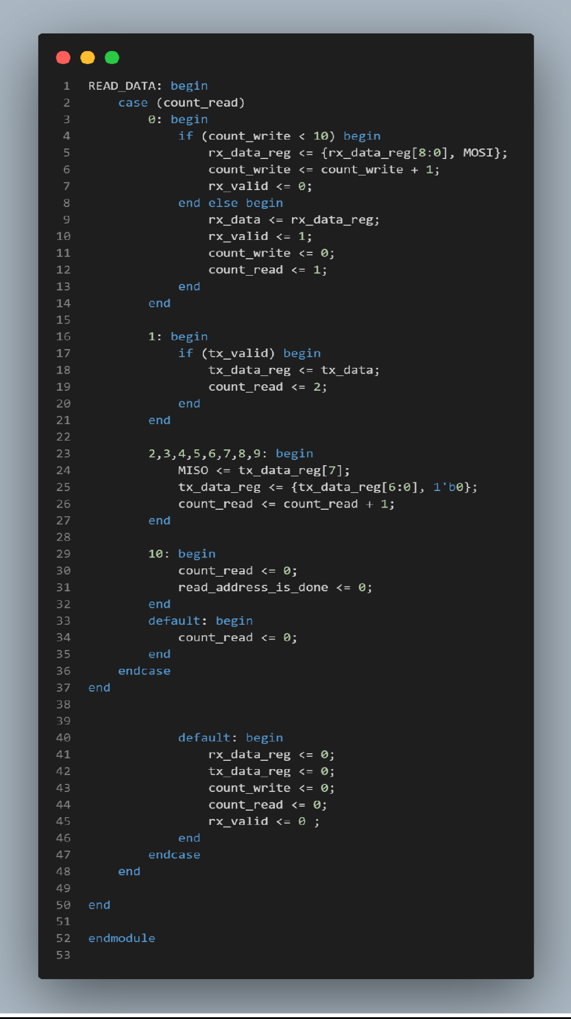

* 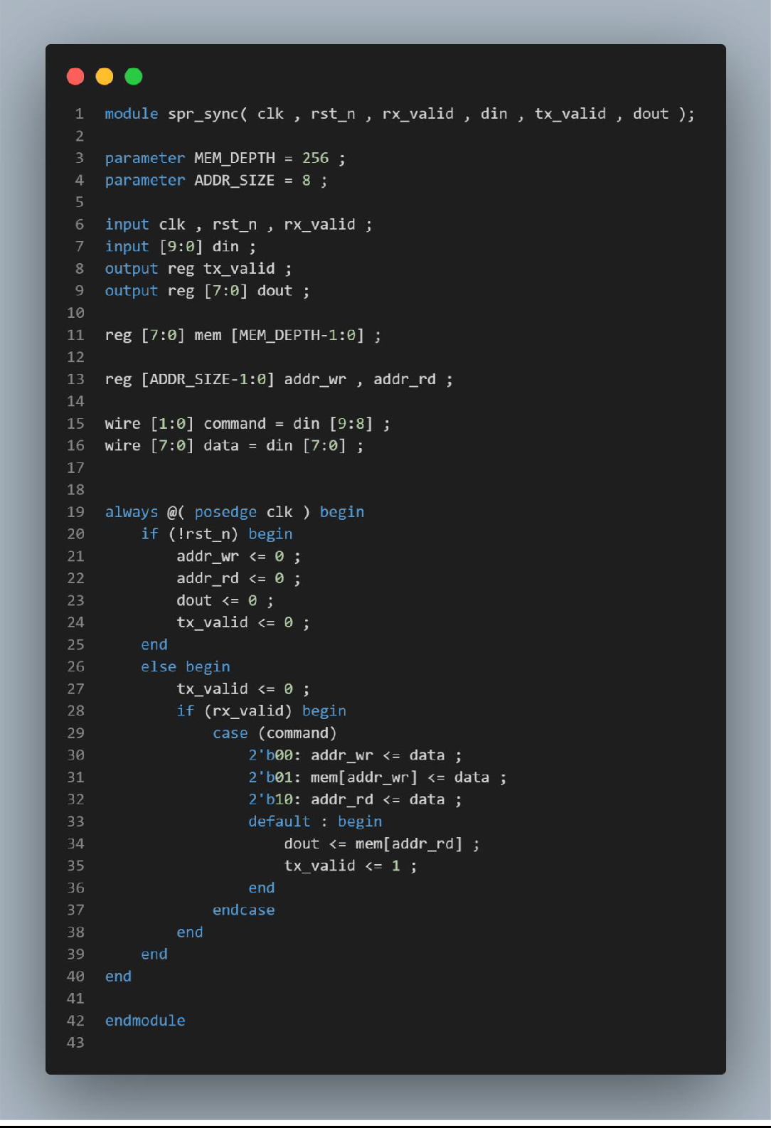RAM Code
* 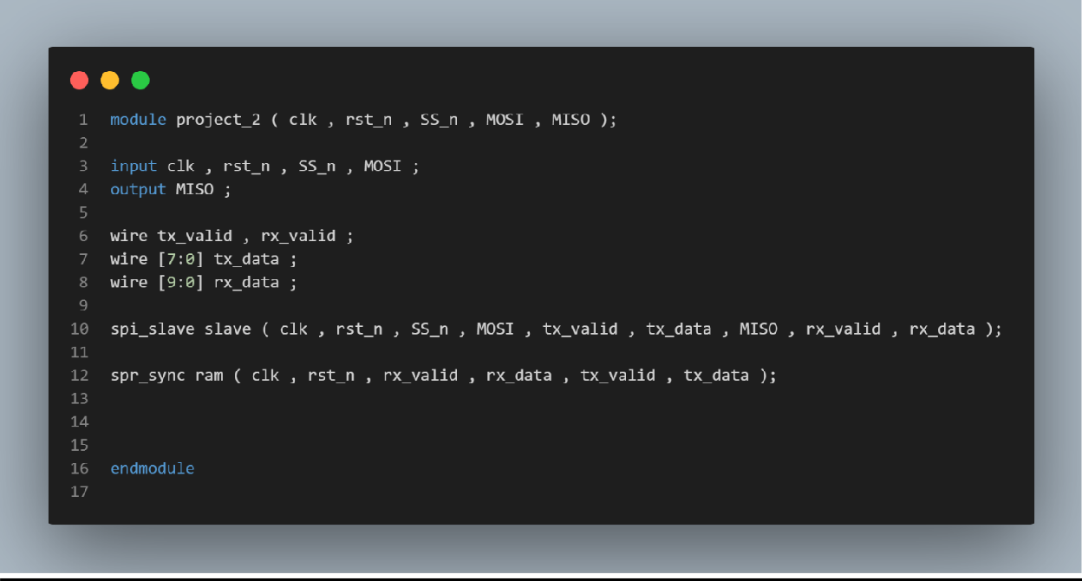Project Code
* Testbench Code

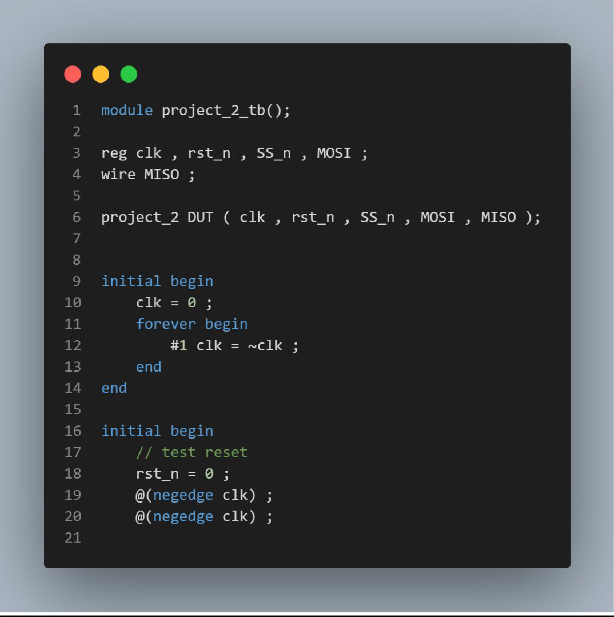

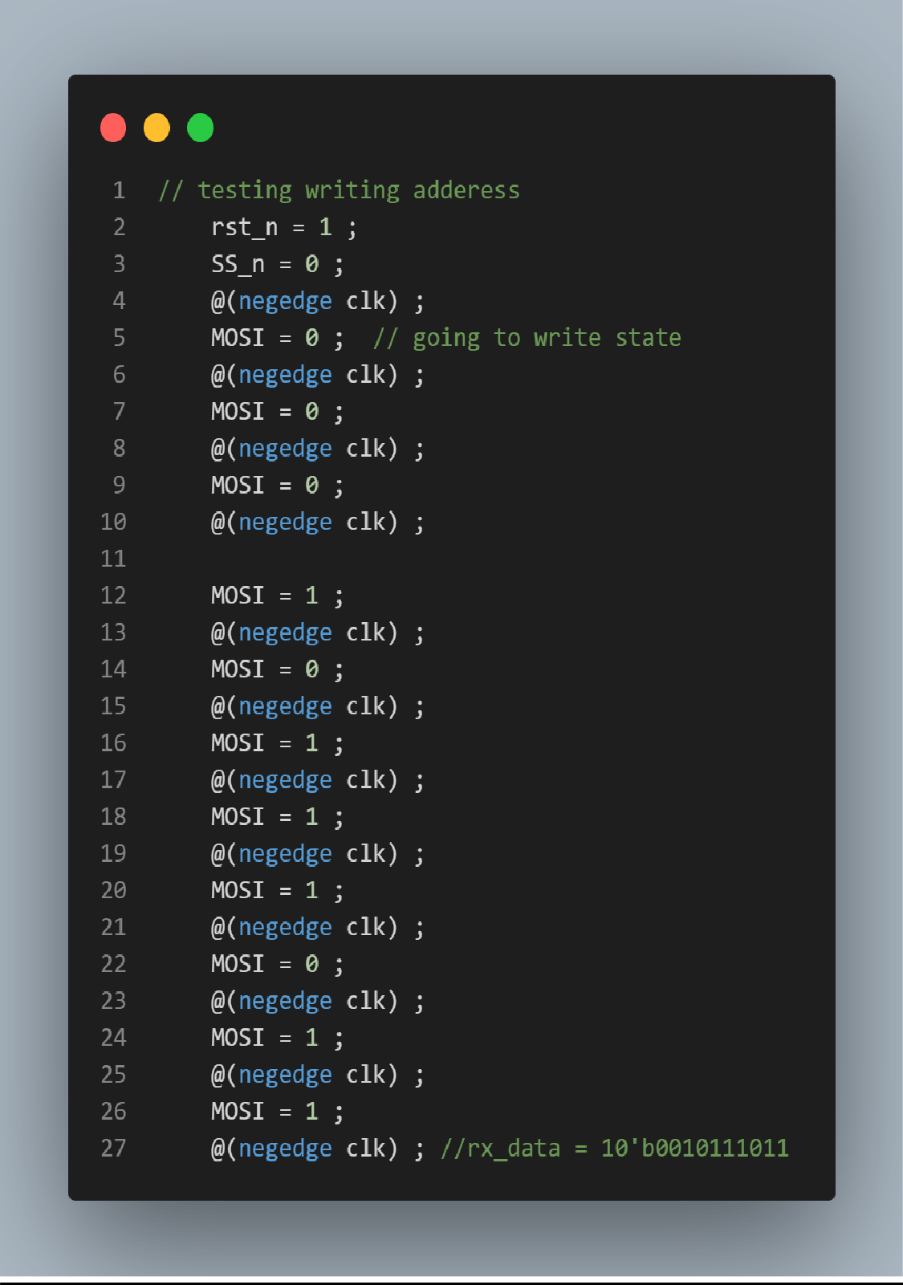

1 t 2 St i ,-.. ', 1·::.: 1,·. _; :-: Jt ,

•••

2 **MOSI** = **0** ,

,\-l ,

.

::.1 ,-,

t i tt:' I ( t (_=i ':•: J: t:'

@(negedge **elk)** ,

4 **MOSI** = **0** ,

- .

*J* @(negedge **elk)** ,

I=; **MOSI** = **1** ,

7 @(negedge **elk)** .,

,-,

,::,

9 **MOSI** = **1** ,

1 @(negedge **elk)** .,

1. **MOSI** = **0** ,
2. @(negedge **elk)** ,.

L! **MOSI** = **1** ,

1. @(negedge **elk)** .,
2. **MOSI** = **1** ,

E @(negedge **elk)** .,

17 **MOSI** = **1** ,

1. @(negedge **elk)** ,.

1=; **MOSI** = **0** ,

) .

*L* @(negedge **elk)** ,

1. **MOSI** = **0** ,
2. @(negedge **elk)** ,.

-) -:1

*L* _.

**MOSI** = **1** , .

24 @(negedge **elk)** ,

1· '.( .-:,:1L1 = 1 11 111 1

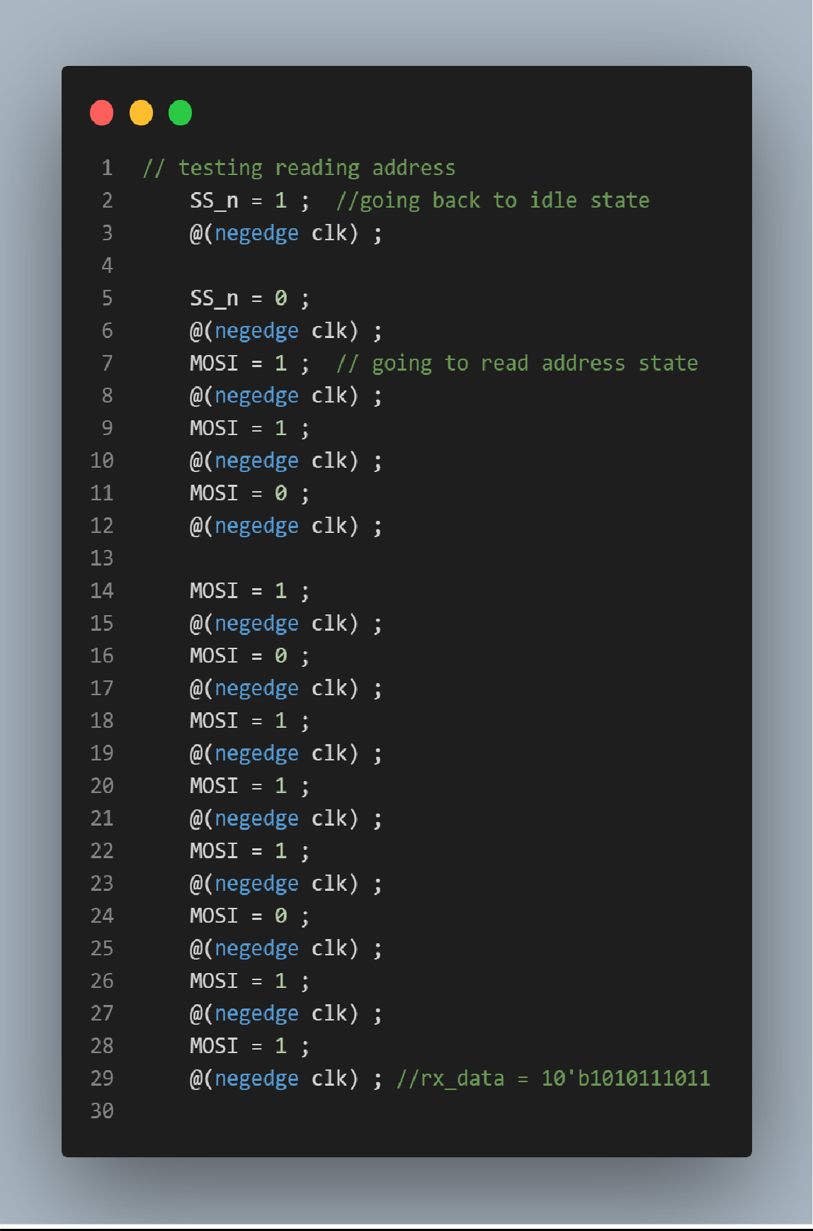

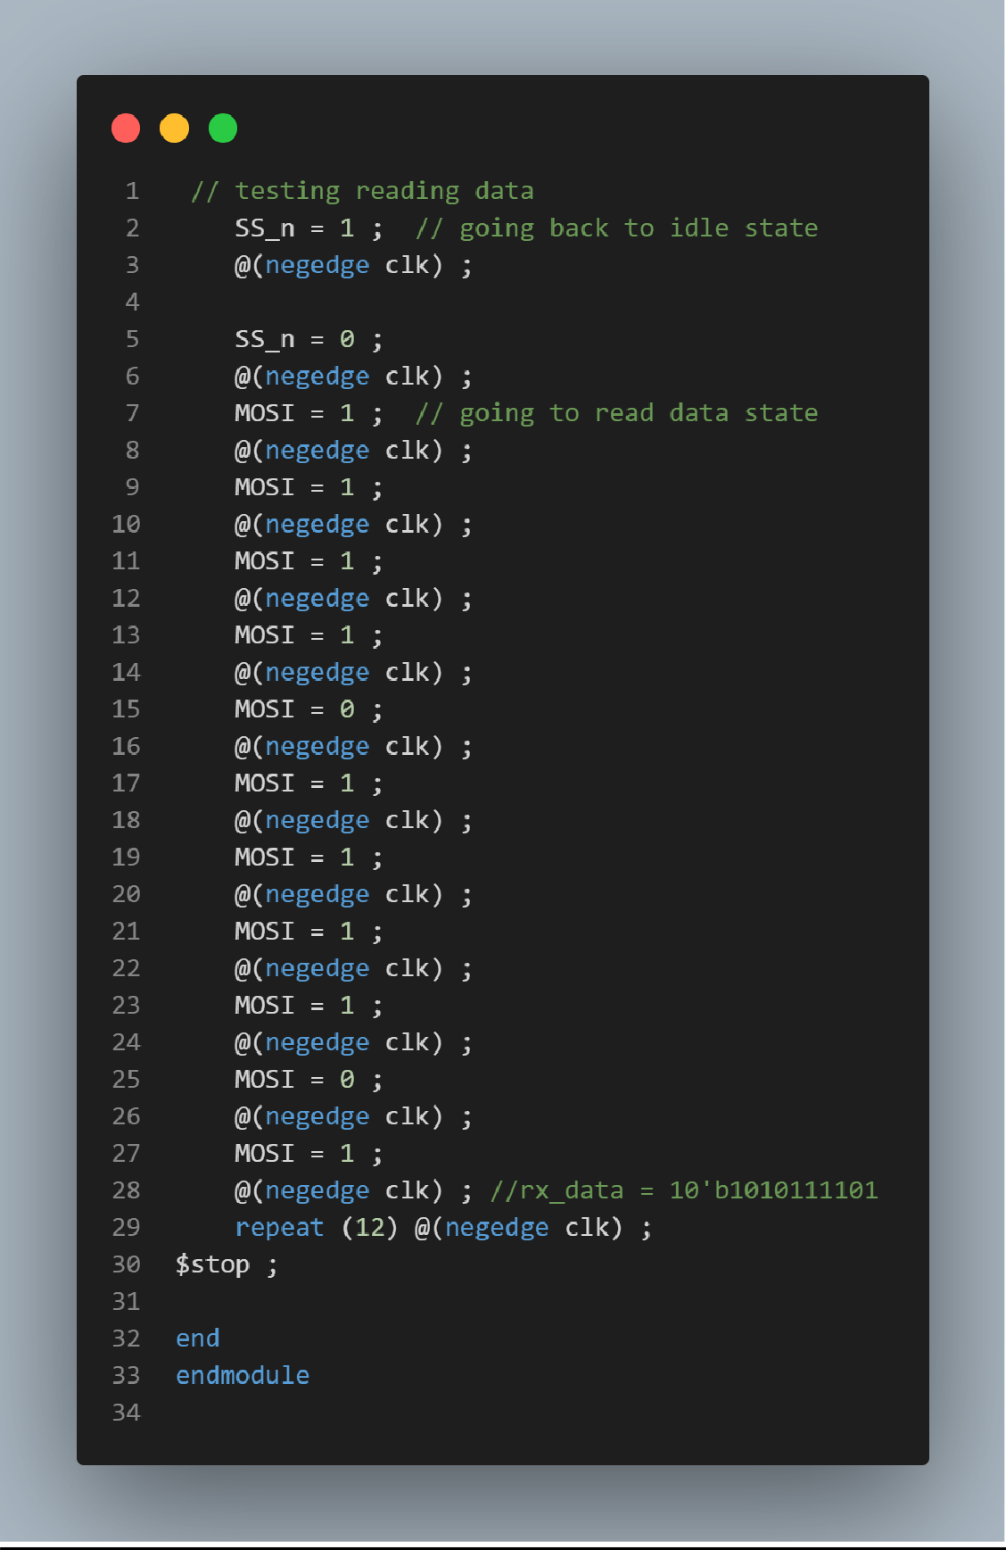

* QuestaSim Snippets

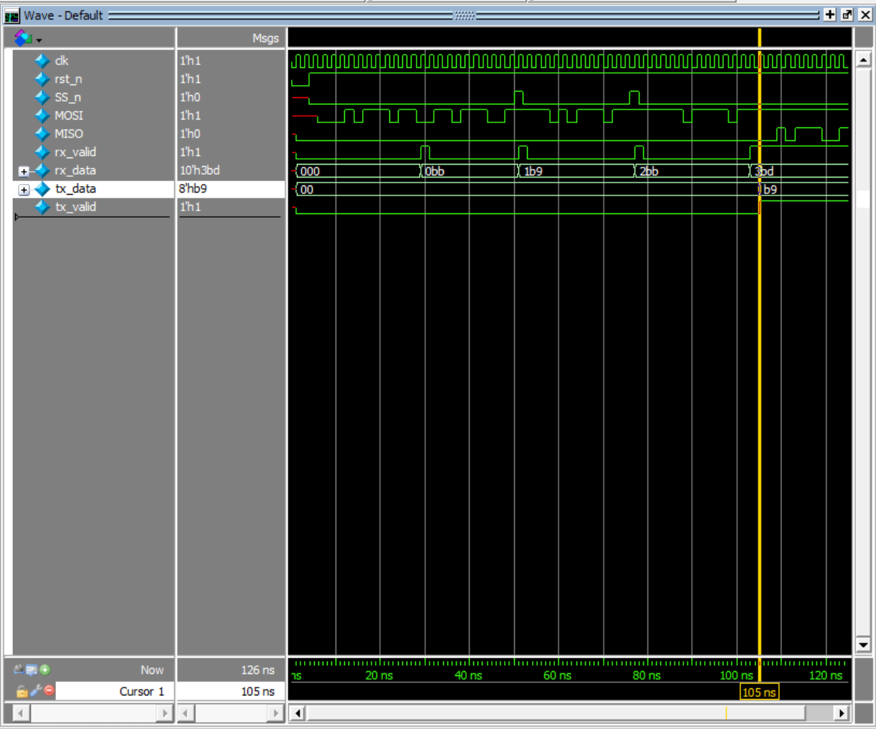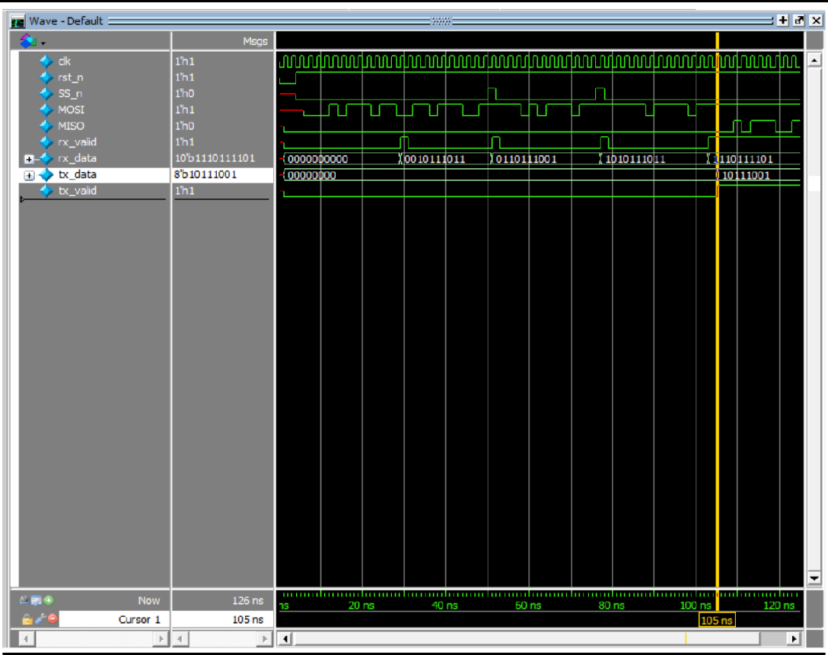

* QuestaLint Snippets

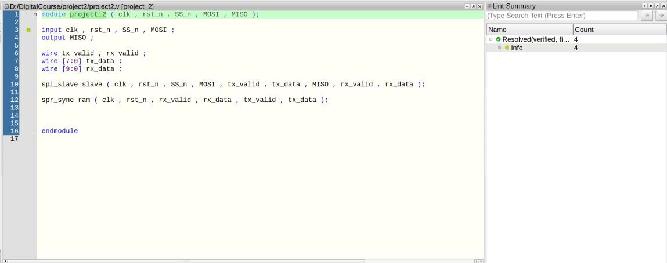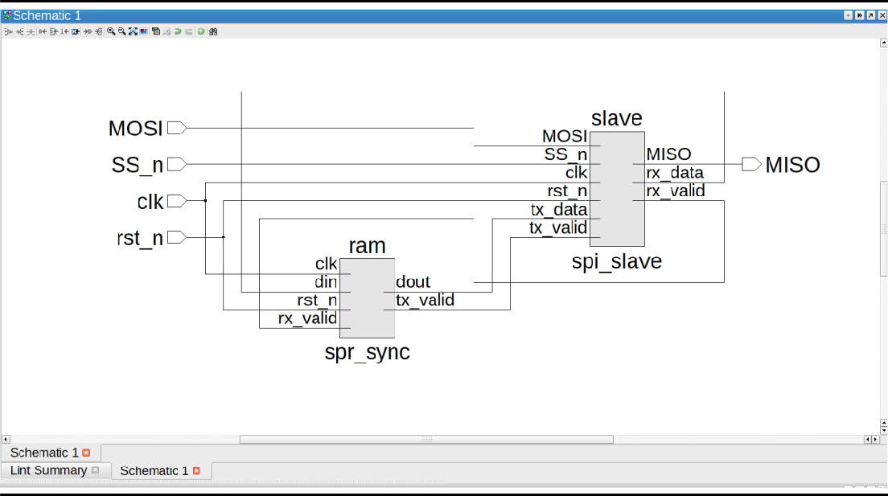

# GRAY Encoding

* Schematic

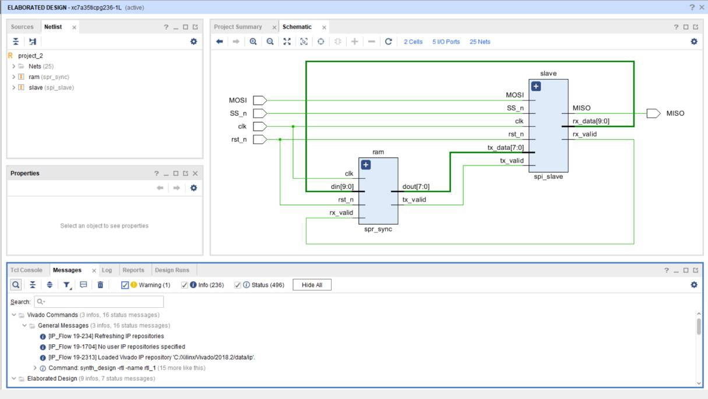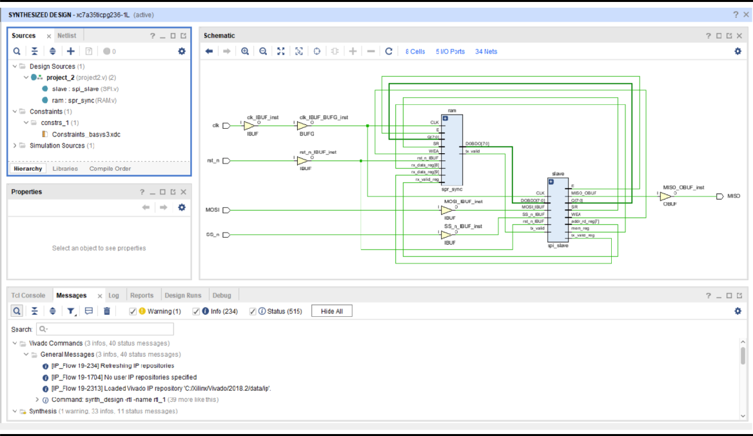

* Synthesis Reports

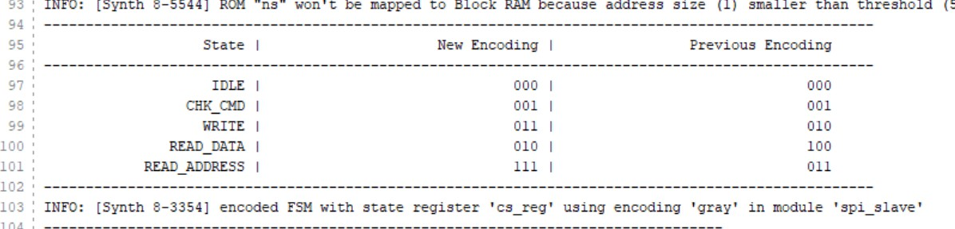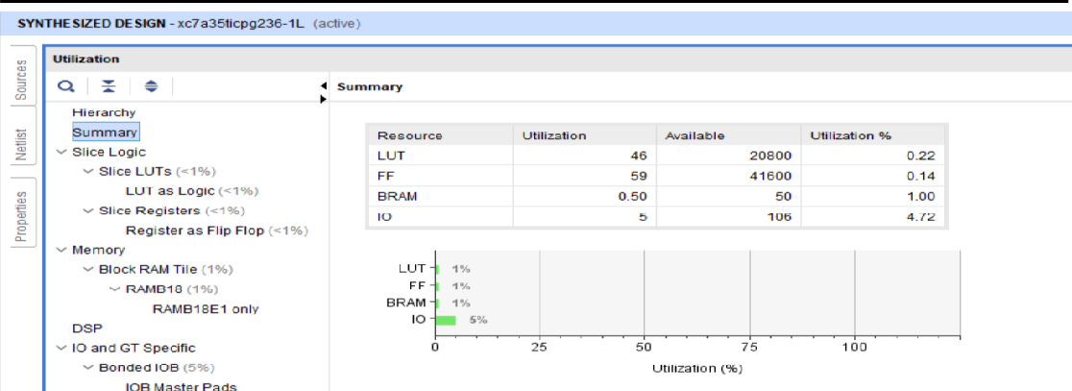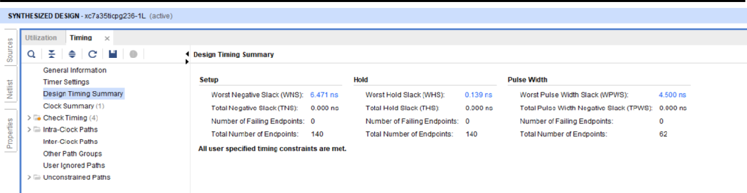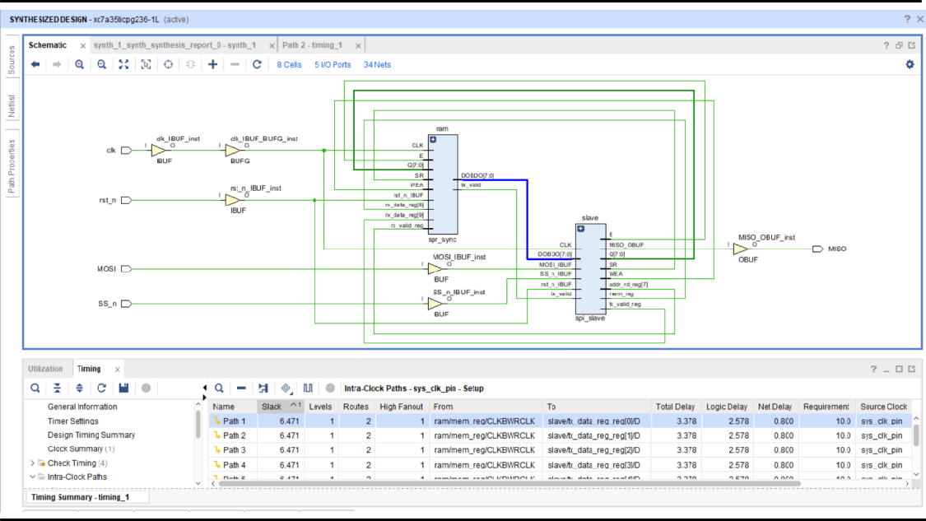

* Implementation

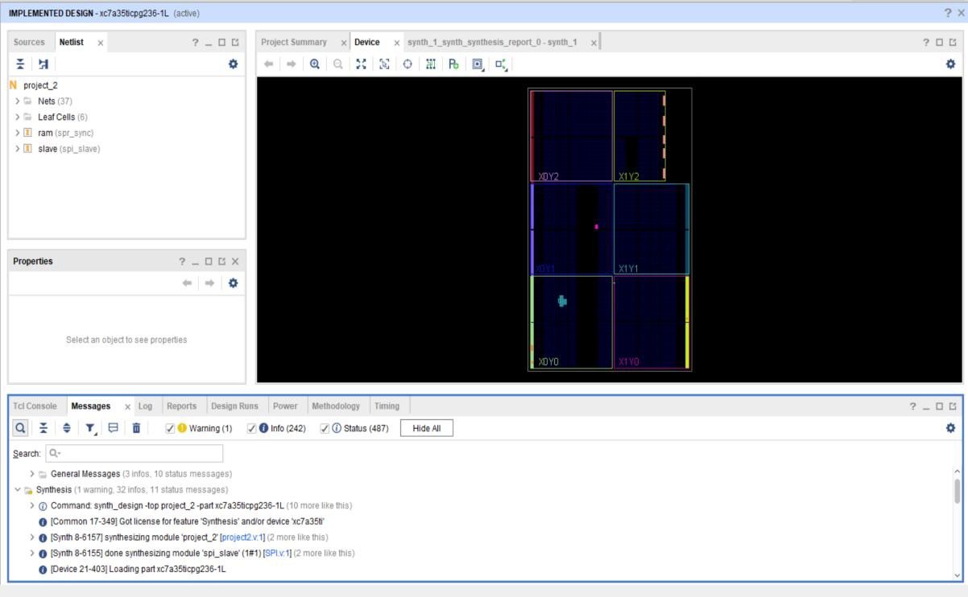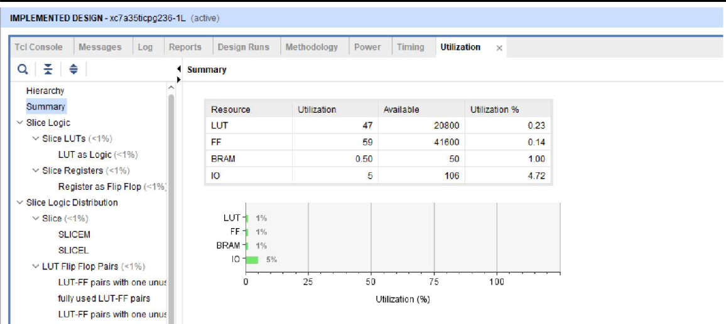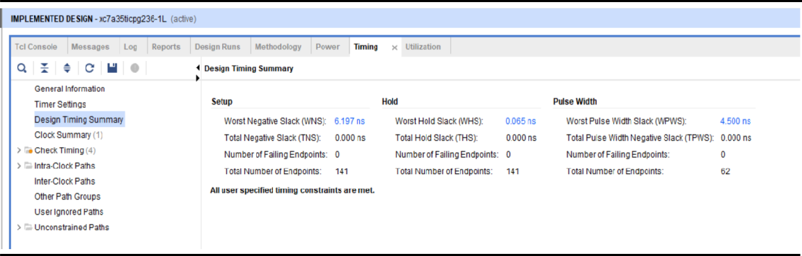

# ONE HOT Encoding

* Schematic

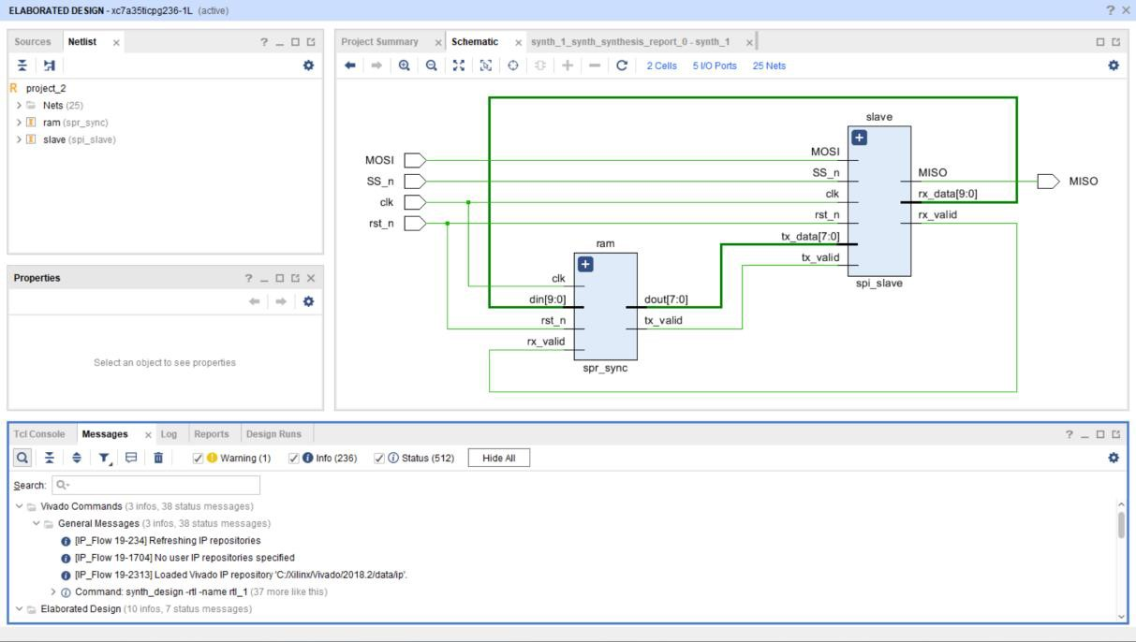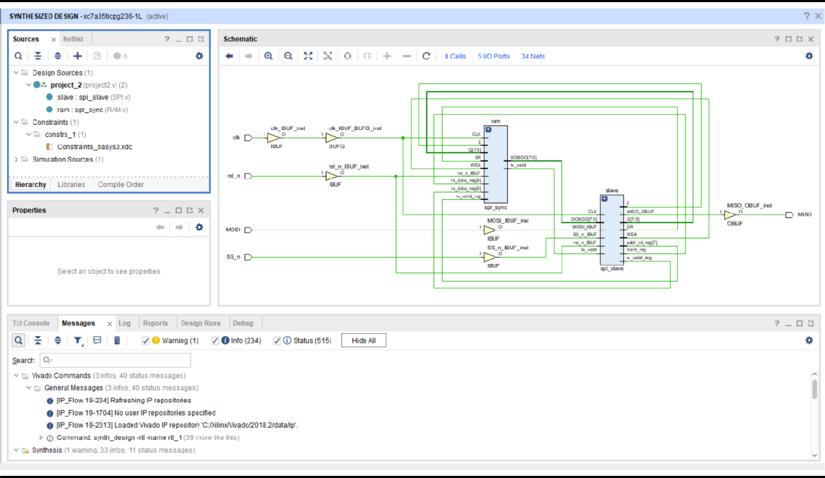

* Synthesis Reports

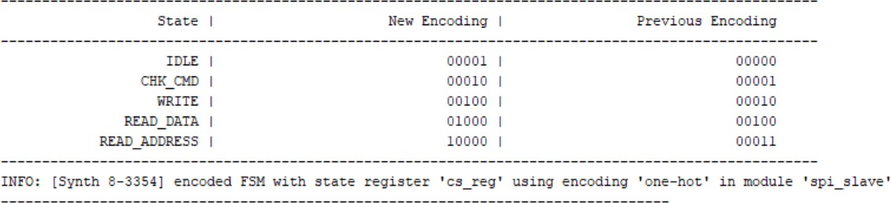

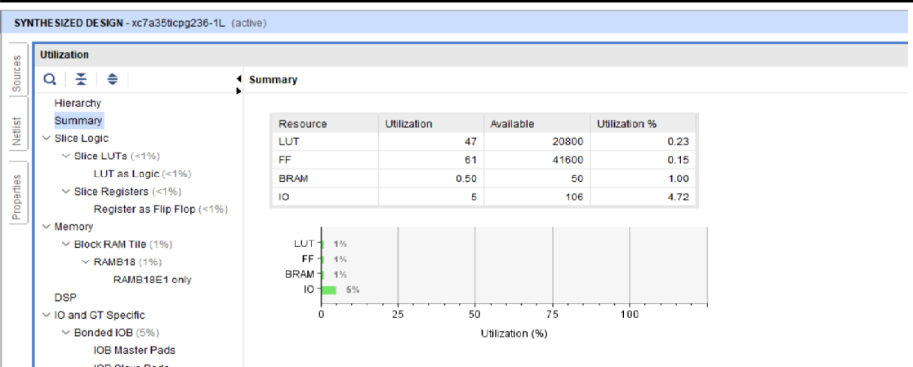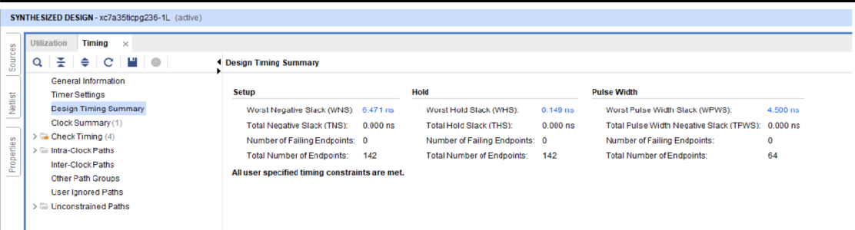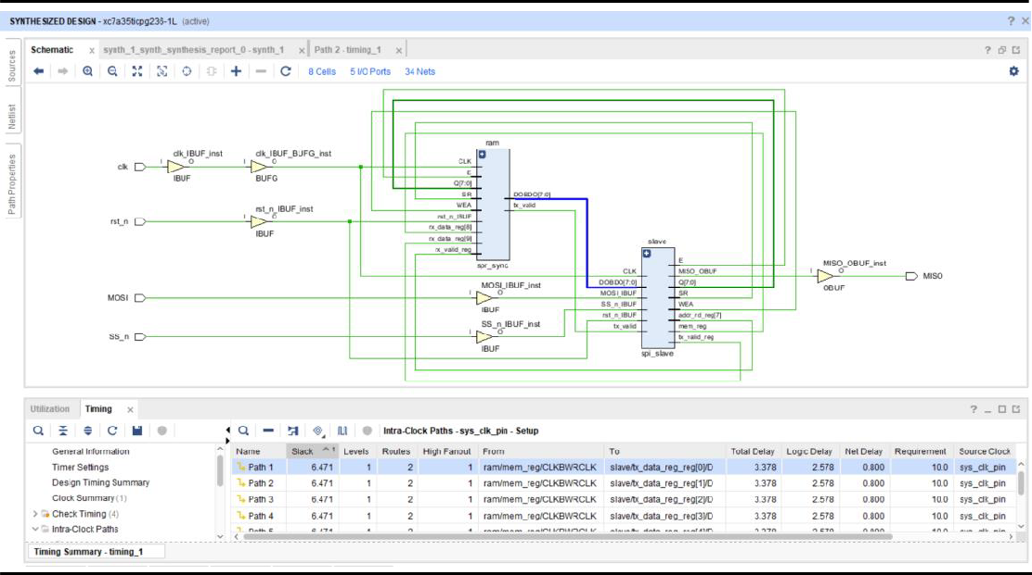

* Implementation

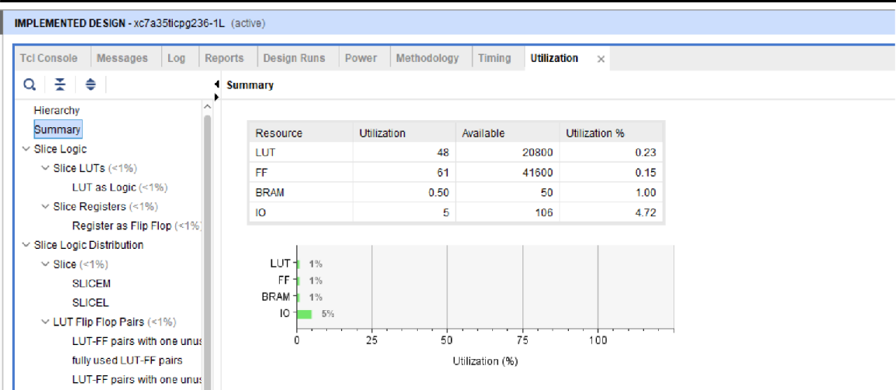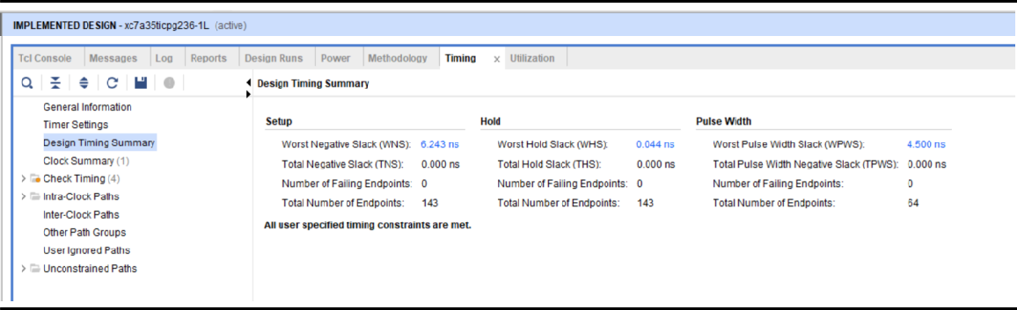

# SEQ Encoding

* Schematic

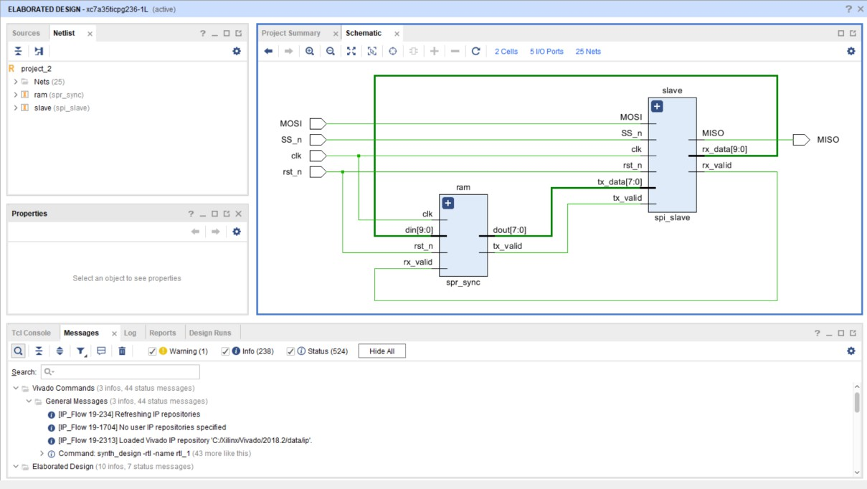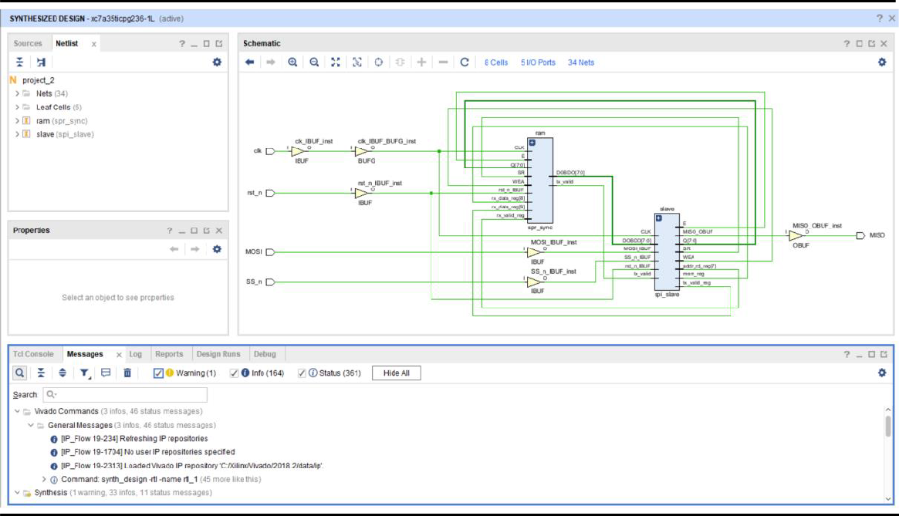

* Synthesis Reports

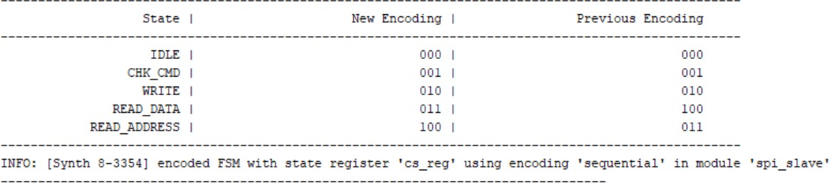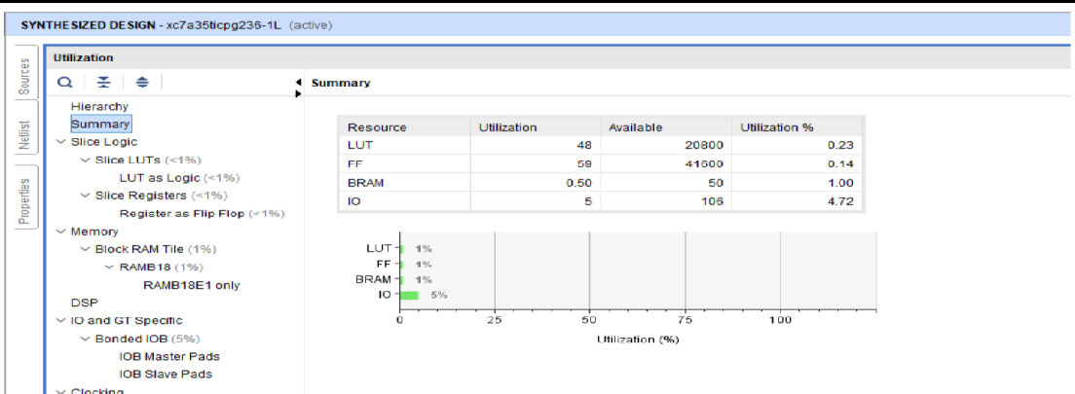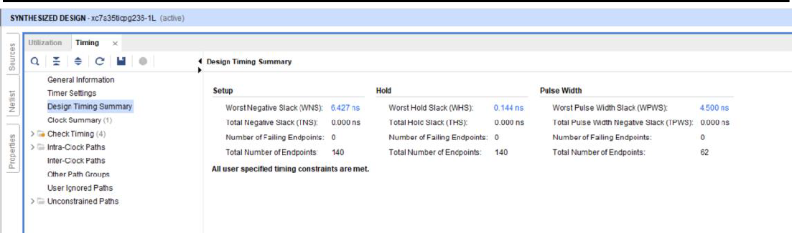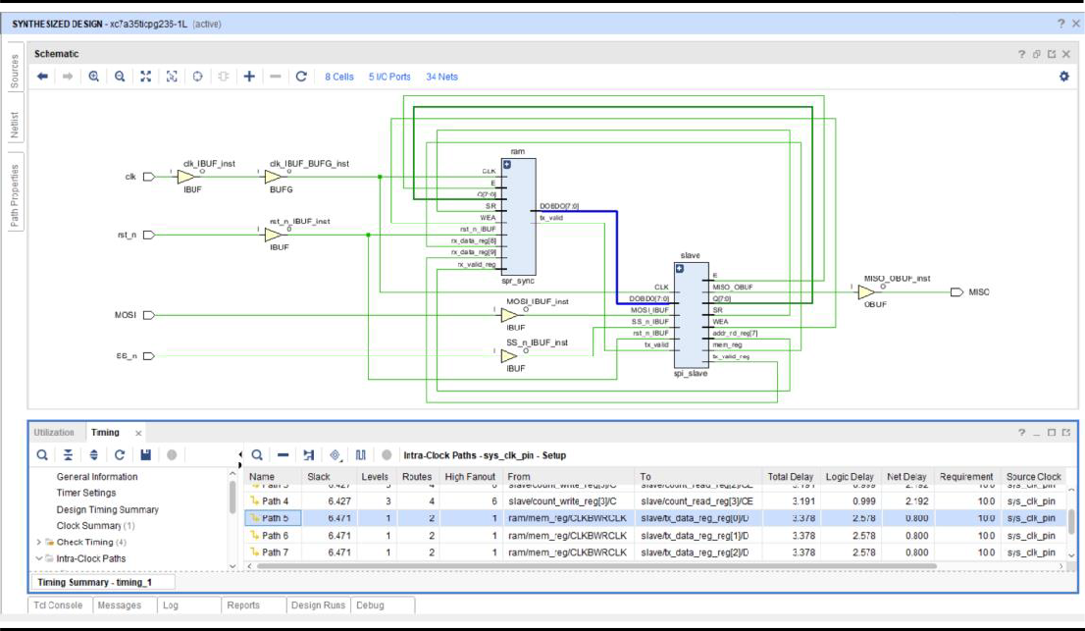

* Implementation

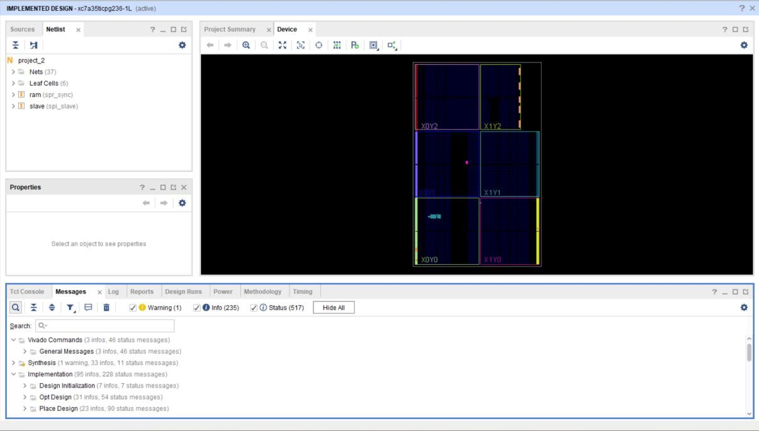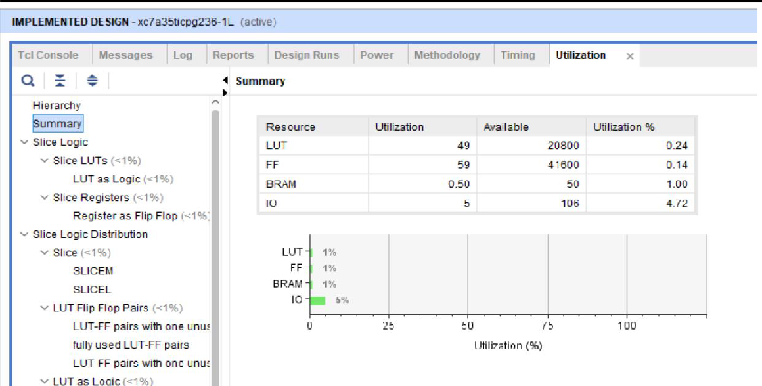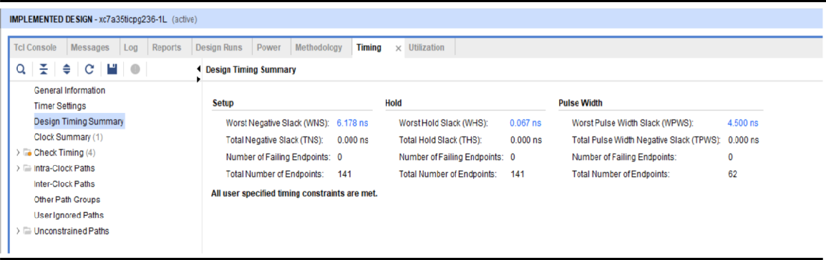

**We chose Gray encoding because it offers the best timing and resource utilization.**

